UL Data Listing & Its Manufacturer Capabilities Highlighted Below
As per the related UL rules and regulation, all the capability of each manufacturer cannot be claimed by herself, but has to be manifested and homologated with UL. Otherwise you are not allowed to print your UL number, model and logo on the boards.
In 2024, the top EMS manufacturers in the world 1. Foxconn, Inventec, AsusTek,Quanta Computer,Taiwan; 2. Flextronics, Venture, GES, Singapore; 3 Jabil, Sanmina-SCI, Benchmark, Plexus, Solectron, USA; 4. Celestica, SMTC, Creation Technologies, Canada; 5 Elcoteq, Scanfil EMS, PKC Group, Finland; 6. Siix, Di-Nikko Engineering,Nippon Manufacturing Service, Japan; 7 NamTai Electronics, WKK Technology Ltd., Hong Kong; 8. Zollner Elektronik, Vogt, German; 9. éolane, ALL CIRCUITS, LACROIX Electronics, France; 10. Enics, Switzerland, etc declared that they will not purchase PCBs not conformed to UL new rules for assembly solder 6 Cycles under min. 260C at https://iq.ulprospector.com/en/profile?e=203598
HD-10 UL list for PCBs with Min. track width only 0.02mm=0.78mil (less than half of the human hair diameter) is so far Number 1 in the world by UL manifested.
HD-MC12 UL list for multilayer PCBs with metal-backed inner layer copper 102um is so far Number 2 in the world.
HD-M29 & HD-M30 UL list for heavy copper PCBs with inner layers copper of 212 um is Number 3 top PCB makers in the world
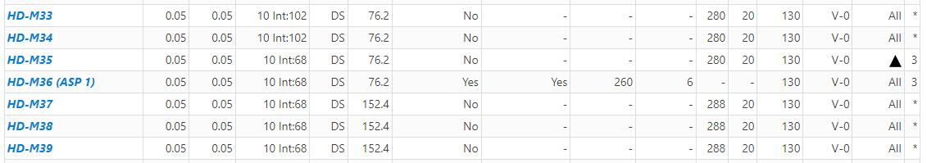

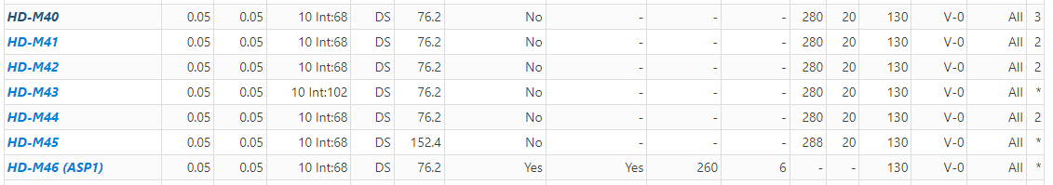
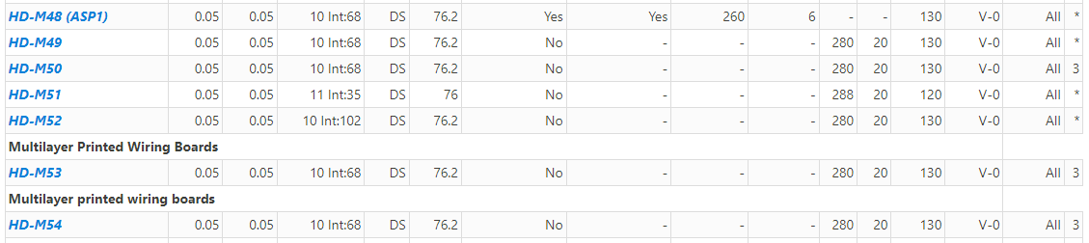
The above 22 UL listings for HDI (High Density Interconnection) & ICS (IC Substrate) PCBs with min. line and space 0.05mm=2 mils are among 6 top PCB makers in the world for 1-n-1,2-n-2, 3-n-3, 4-n-4 PCB or anylayer
Among HD-M36,HD-M46 & HD-M48 UL list for HDI & ICS PCBs are updated to the highest level as per UL new rules for assembly solder temperature 260C at 6 cycles for product service life more than 10 years and 99% PCB makers in China and world are not upgraded or only less than 1% upgraded to 1--3 cycles for product life 1--5 years.

